Android Continuous Integration and Delivery

With Jenkins+Git+Gradle

# Step 1 Install Jenkins

Before install Jenkins, the compute should have

* + 256 MB of RAM, although more than 512MB is recommended
  + 10 GB of drive space
  + Java 8 or higher (either a JRE or Java Development Kit (JDK) is fine

1. Go Jenkins’s official website <https://jenkins.io/download/>, download LTS (Long-Term Support) releases for your operating system
2. Run jekins.msi to install for Windows.
3. Go <http://www.oracle.com/technetwork/java/javase/downloads/jdk10-downloads-4416644.html>? to download and install JDK
4. Go <https://git-scm.com/downloads> to download and install git.

After installing, Jenkins will be a Windows service. It can be start/restart/stop in Windows service management

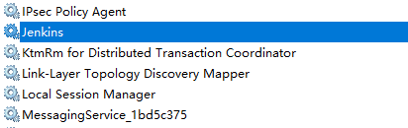

Figure 1 Windows service management

# Step 2 Set up Jenkins Plugins

1. Open http://localhost:8080 in browser
2. Select “Manage Jenkins” from left Menu
3. Select “Global Tool Configuration” from right Menu
4. Set up JDK, Git, Gradle as following, if there is no such option, go “Manage Jenkins>Manage plugins” to install them

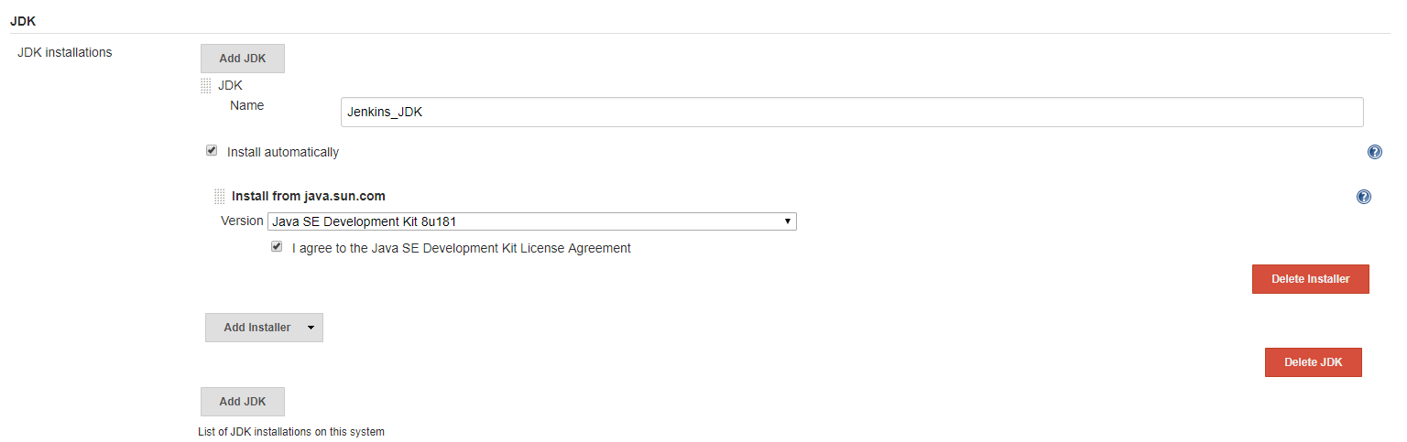  
  
Figure 2 JDK Setting

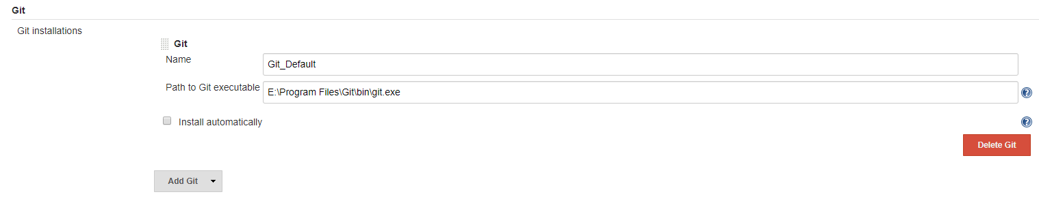

Figure 3 Git Setting

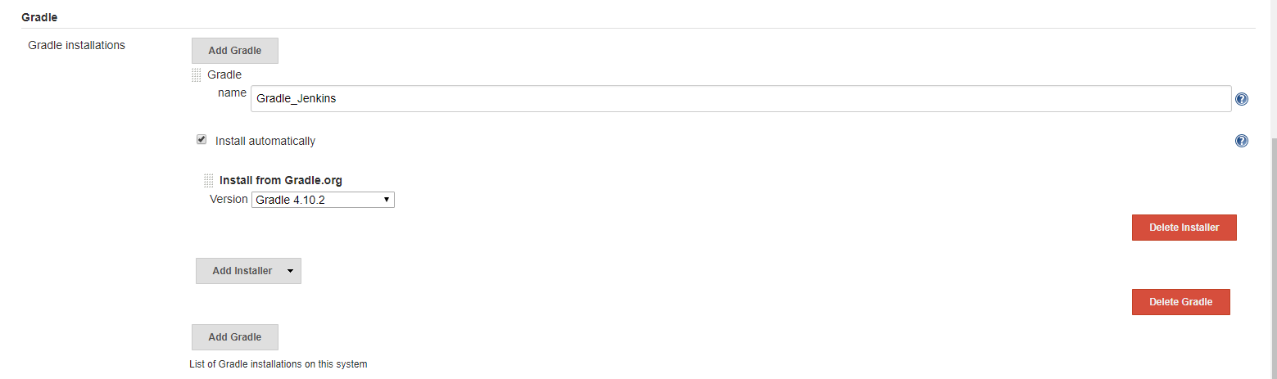

Figure 4 Gradle Setting

# Step 3 Create Project Item

1. Go “New Item”, input item name and select Freestyle project

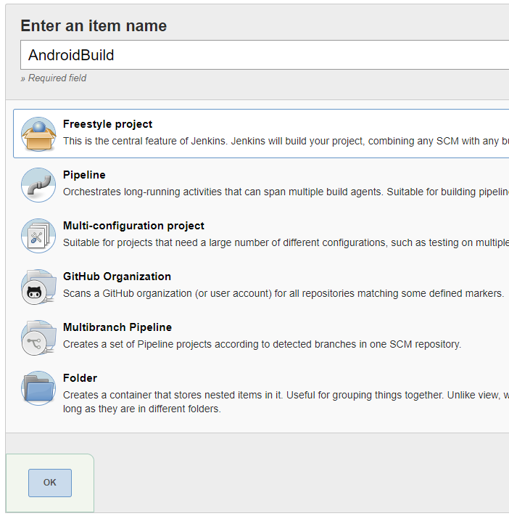

Figure 5 Add item

2. Set up Source Code Management by setting GitHub clone URL and credential

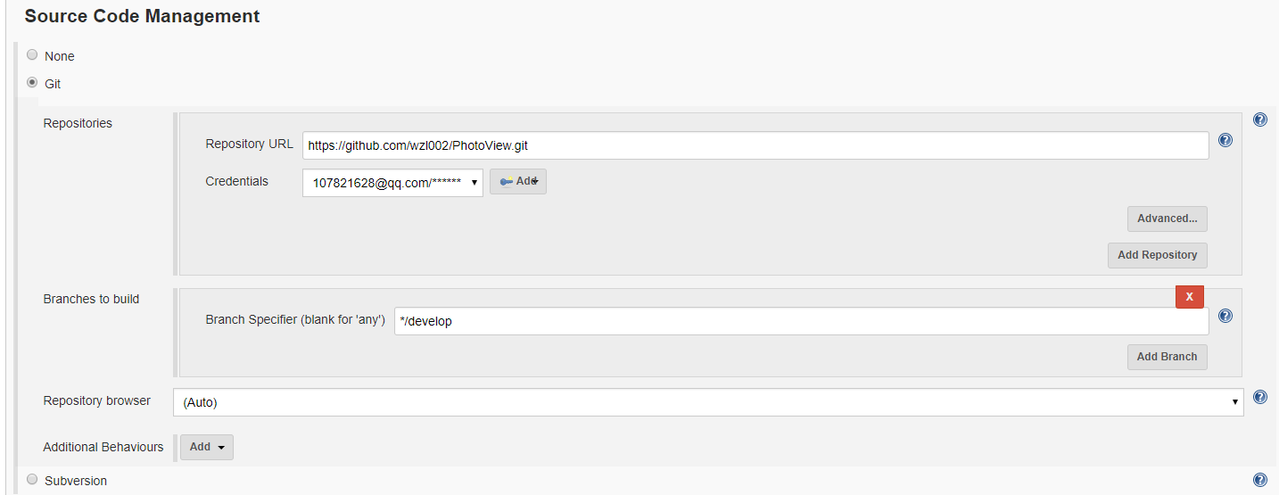

Figure 6 Config Item Git

3. Set up Build task with Gradle wrapper

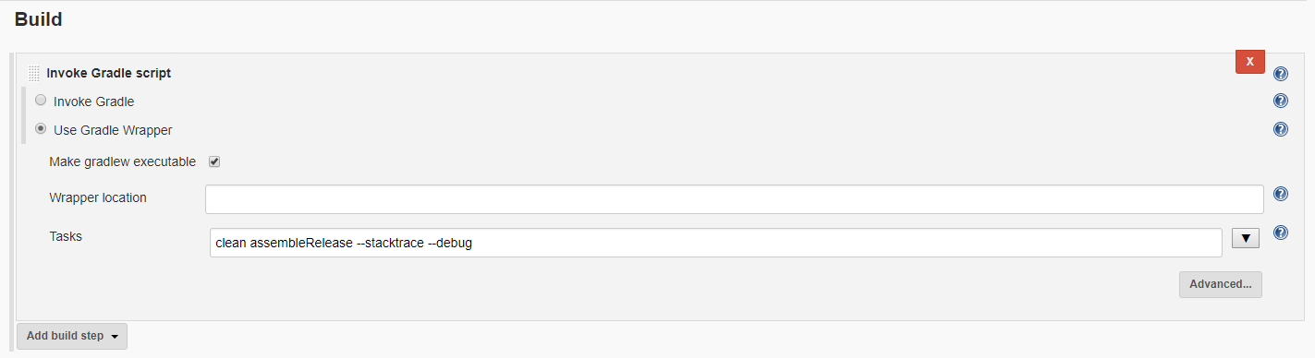

Figure 7 Config Item Gradle

# Step 4 Build Project

# Go item page, select “Build Now”

